### Net bandage

PM11009

Material: Acrylic with Elastic

Color: White

Weight: 120g/m2

Packing: Iroll/poly Bag

Size: O.8cmx25m, 1.7cmx25m, 2cmx25m, 2.2 cmx25m, 2.6cmx25m, 3.8cmx25m, 4.4cmx25 m, 5.5cmx25m, 6.8cmx25m, 8cmx25m

### صورة تحتوي على ضمادة, ملحقات, داخلي تم إنشاء الوصف تلقائياًStockinet Bandages

PM11008

Material: 100% Cotton

Color: Natural white or other color per Customer's demand

Introduction: Made from 100% natural Cotton, which is used for the wound and

Sport. It can be made into roll.

Packing: Iroll/poly Bag

Size: 5.0cm x20 m, 6.0cm x20 m, 7.5cm x20m, 8.0cm x20 m, 10cm x20 m, 15cm x20 m,20cm x20m

### Absorbent cotton wool

PM11013

Absorbent Coton Wod

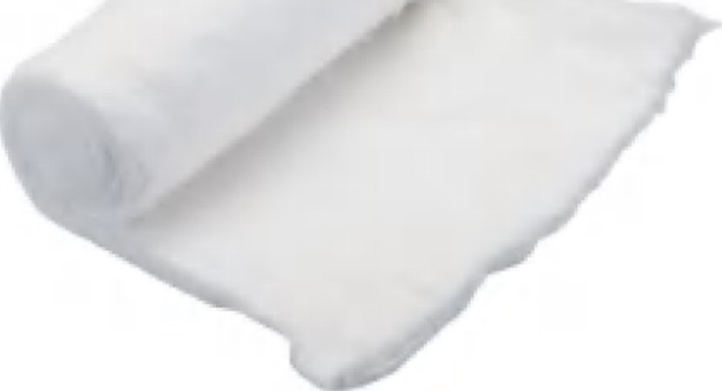Introduction:Made from 100% natural Cotton After cleaning,purifying andBleaching, which Is used for cleaning the Wound. It can be made into roll.

Grade of Cotton:Natural or Super Absorbent Packing :Each roll in Blue kraft paper Packing

Weight/Roll: 50Gram, 100Gram, 125Gram, 150Gram, 200Gram, 400Gram, 454Gram, 500Gram, 1000Gram etc.

### Hydrocolloid Dressing

PM11040

Excellent exudates absorption capability.

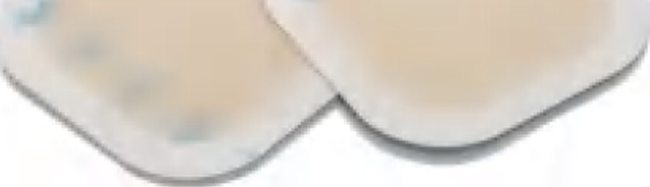Keep the wound in a moist environment, Promote wound healing,effectively release pains and reduce wound care frequencyl Water-proof,protect the wound from microbia invasion.

Excellent elasticith and self-adhesive, convenient and comfortable to wear.

Please change the dressing when it turns white. Easy to peel off,no adherence to wound,so Effectively reduce the potential Damage and pains. Available in different sizes and shaps to Meet the needs. Packed in blister bag

#### Size:5x5cm/7.5x7.5cm/10x10cm

part Disposable

PM10010

Material: PVC

Parts: Barrel+Plunger+Needle (or without needle)

Luer Lock or Luer Slip Packed in individual PE bag

Size:2/5/10/20ml